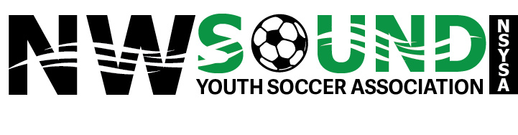

Northwest Sound Youth Soccer Association Scholarship Application

Eligibility: Applicants must have been a current or former member of the Northwest Sound Youth Soccer Association (NSYSA) as a registered player, coach, or referee. NSYSA member clubs include Bainbridge Island Youth SC, Bremerton SC, Central Kitsap SC, Jefferson County SC, Kitsap Alliance FC, North Kitsap SC, North Mason Youth SC, South Kitsap SC, Storm King SC, and Tracyton SC.

Terms: Scholarships of up to $1,000 will be awarded to candidates who are in their senior year of high school or equivalent. Scholarships are only to be used for tuition, fees, books, supplies, and room and board at a post-secondary institution (college, university, or technical/vocational school). Disbursal of scholarship monies will be made directly to the institution.
Deadline: Applications postmarked after March 31, 2024, will not be considered.

Applicant Name: ____________________________________________________________________________________

NSYSA Role (check all that apply): player coach referee

NSYSA Club: _______________________________________________________________________________________

Mailing Address: ____________________________________________________________________________________

Phone Number: _____________________________________________________________________________________

Email Address: ______________________________________________________________________________________
I will graduate from: _________________________________________________________________________________

I plan on attending: __________________________________________________________________________________
Name of post-secondary institution

Have you been accepted to this institution? ______________________________________________________________

Financial Information
Anticipated costs for next year
Other scholarships received

Please include the following items with this completed application form
- Official transcript – Please also include a copy of the classes in which you are currently enrolled.
- Essay - On a separate sheet of paper, please describe in 500 words or less why you believe your involvement in soccer has impacted your life as well as the lives of those around you. Include examples of the impact YOU have personally seen because of your soccer experiences. Also include your career goals, why you have chosen that career path, and why you would be a good choice for this scholarship.
- Soccer Resume – On separate sheet of paper, please include your soccer resume in chronological order beginning with your most recent involvement. Include the name of the Club (or referee association) for which you played, coached, or volunteered as well as the year(s) you participated.
- Letter of Recommendation - Include one letter of recommendation from someone who knows about your soccer involvement. The letter should be from a teacher, coach, or other non-family member who can attest to your involvement in youth soccer.

Community Service
Volunteer Organization | Accomplishments | Years of involvement

School Activities/Accomplishments
Sport/Organization/Activity/Club | Position | Accomplishments | Years of involvement

Non-school Activities/Clubs/Organizations/Work/Leadership
Sport/Organization/Activity/Club/Work | Position | Accomplishments | Years of involvement
Non-school Activities/Clubs/Organizations/Work/Leadership (cont.)

List any other honors or awards:

Please mail your complete application to the address below. Applications postmarked after the deadline of March 31, 2024 will not be considered.
MAIL TO: NSYSA
Attn: Scholarship Committee
P.O. Box 1142
Silverdale, WA 98383

Please direct questions to nsysa.scholarship@nsysasoccer.org

